POLICY
Complete Policy Title:  Key Control Policy | Policy Number (if applicable):
Approved by:  Vice-President (Administration) | Date of Most Recent Approval:  June , 2021
Date of Original Approval(s): | Supersedes/Amends Policy dated:  June 8, 2011
Responsible Executive:  AVP, Facility Services | Enquiries:  Facility Services
DISCLAIMER: If there is a Discrepancy between this electronic policy and the written copy held by the policy owner, the written copy prevails.

Policies, Procedures and Guidelines

  - It is the policy of McMaster University to provide and maintain an open study, research, and work environment, and to provide safe conditions on its premises by regulating the issuance and control of keys related to the accessing of University property.

SCOPE

  - To provide a system for the issuance and control of all keys related to the operation of McMaster University (all owned locations on and off campus), and the replacement, repair and maintenance of lock cylinders.

PURPOSE

  - A Key Control Policy is to establish reasonable personal security for members of the University community and to ensure the protection of personal and University property through the control of the distribution of keys.

PROCEDURE

  - Issuance

    - Eligibility

      - Only faculty, staff, students and approved visitors may be issued keys.

    - Authority

      - The issuance of keys must be authorized by the appropriate person in accordance with Keying Structure and Authorization Levels noted in Appendix 1.

      - It is the responsibility of the Faculty, Department or Sub-Department to keep record of who is in possession of each key that has been issued to them.

      - For the purpose of this policy, the person tasked with key record keeping is the Departmental Key Clerk. A completed Key Clerk Authorization Form, shown in Appendix 2, must be supplied to Facility Services.

    - Procedure

      - Faculty, staff or students requiring keys must submit their request to their Departmental Key Clerk

      - The Departmental Key Clerk will attain the necessary authorization for the key and will log into the Simple K key software system using their credentials as provided to them by Facility Services.

      - Facility Services will confirm the authorization and cut the key. The key will be issued to the Departmental Key Clerk. The Key Clerk will pick the key up from Facility Services when the key is ready. The Key Clerk will sign having received the key. Facility Services will retain the signed record that the key has been cut and received by the Department requesting the key. This information will be retained in Simple K

Care

    - All keys will remain the property of the University at all times. The proper use and care of the keys is the responsibility of the individual to whom the keys are issued. Keys must not be loaned, duplicated or used in an unauthorized manner.

Return

    - Keys shall be returned to the Departmental Key Clerk by the individual to whom the keys were issued as follows:

      - Upon transfer to another department, position or building.

      - Upon resignation, retirement or termination.

      - Upon completion of the temporary issue period as specified on the Key Request Form.

      - Upon the request of the authorizing persons outlined in Appendix 1.

Padlock, Peripheral and Personal Lock Policy

    - All padlocks to doors or gates affecting University property must be compatible with the authorized key control system.

    - All locks and keys to these locks will be controlled in accordance with this policy.

    - Keys to file cabinets, desk drawers, and personal lockers are not included within this policy and will remain the responsibility for the person in charge of the area.

Numbering Systems for Keys

    - An identifying serial number will be stamped on each key for record purposes.

    - Only one key for a specific area, room or door will be issued to any one person.

Lost or Stolen Keys

    - Lost or stolen keys must be reported immediately to Security Services (security@mcmaster.ca or x24281). A new key will not be issued to anyone unless an Incident Report completed by Security Services is on file.

    - The charge to replace a key will be the same as the issuance of a key and will be done in accordance with Rekeying Costs as noted in Appendix 3.

    - Charges for cylinder replacement or pin combination change, if this is required as a result of a lost or stolen key, shall be done in accordance with Appendix 3.

    - All pieces of a broken key must be returned to Facility Services or accounted for before a replacement key may be issued.

    - Depending on the Departmental arrangement, the key holder may be personally responsible for the replacement cost of keys that are lost or stolen and for rekeying costs, while the key is in their possession.

Repair of Locks, Keys or Door Hardware

    - McMaster University is a licensed user of the Medeco Keying System. As a high security system, a number of restrictions are required by the manufacturer to maintain the integrity of the system.

    - All repairs or additions to any locking device, key or door hardware installed by the University shall be performed by Facility Services staff and documented with a numbered work order. If a change to an access combination is made rendering the old key inoperable, the change must be noted, and the key control records changed to reflect the new key code.

    - Only personnel or contractors authorized by Facility Services shall repair a University lock or cut a university key.

Facility Services Staff

    - Permanent assignment of keys to service staff in Facility Services to campus buildings shall be made only in cases of demonstrated need for operation, safety and security reasons. (In many cases assignment will be to Supervisors only.)

    - Temporary assignment of keys for service staff allowing access to work areas for the period of a day or two can be made through the Facility Services Department. Keys will be issued using a sign out system (i.e. Keywatcher), so that a record of who has been temporarily issued keys is maintained.

    - Keys shall not be issued to cleaning staff for designated high security areas without the written permission of the Dean or designate in charge.

Key Issuance to Outside Contractors

    - Repairs of campus facilities which require a contractor to be issued a key to any campus building must be approved by the Departmental Key Clerk and the authorized signing authority issuing the key to the contractor. The contractor shall be issued and shall return the key(s) in accordance with this policy. A release must be signed by the contractor to deduct funds from the amount owing on the contract for the cost of rekeying in accordance with Appendix 4 if the key is lost or stolen.

RESPONSIBILITY

  - Keyholder

    - Will be responsible for caring for the keys in their possession in accordance with section 4.2.1. May be responsible for the replacement cost of keys that are lost or stolen and for rekeying costs.

Departmental Chair/Director and Key Clerk

    - To ensure that keys are returned to the Department upon resignation, retirement, transfer, or termination of any key holder. Records of keys and key holders are maintained in a secure and confidential manner.

Facility Services - Security Services

    - Investigate and record lost or stolen key reports.

Facility Services - Maintenance

    - Control all repairs and additions to any locking device, key or door hardware installed by the University.

    - Document all rekeying with a numbered work order and note all key control records changed to reflect the new key code.

Deans/Supervisors

    - Provide written permission to cleaning staff to obtain keys for high security or sensitive areas.

COSTS

  - See Appendix 3.

ACCOUNTABILITY

  - All persons are accountable to their supervisors for adherence to this policy.

APPENDIX 1

Keying Structure and Authorization Levels

Key Level | Key Use | Eligible Key Holder | Authorization
GGGGM  Great Great Great Grand Master | Campus | None – Key Not Issued | N/A
GGGM  Great Great Grand Master | Divisions | Security Services | - Director, Security Services, and  - Assistant Vice-President, Facility Services
GGM  Great Grand Master | Building Complexes | Facility Services | 1) Assistant Vice-President, Facility Services
M  Master | Building | - Faculty Dean  - Area Director  - Administrative Assistants | - Dean and  - Area Director
SM  Sub Master | Department or Unit within Department | - Department Chair  - Administrative Assistants | 1) Department Chair/Director
Change Key | Individual Doors or Sets of Doors Keyed Alike | - Faculty  - Staff  - Students  - Approved Visitors | 1) Department Chair/Director or Department Key Clerk

APPENDIX 2

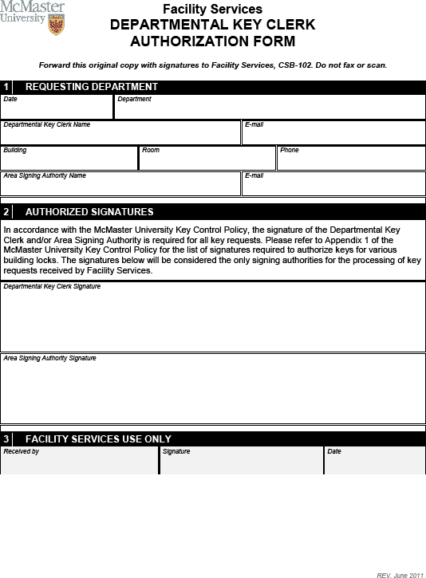

APPENDIX 3

Rekeying Costs (2021/22 Fiscal Year)

- Replace single core:

$200.00 each, includes labour and material. This does not include the cost of keys.

- Rekey existing Medeco door cylinder with no change in function (change combination):

$20.00 pin kit + 1 hour = $100.00
This does not include the cost of keys.

- Cost of keys (original or replacement) $20.00 each.

- Should rekeying of an area be required cost shall be $200.00 per lockset multiplied by the number of lock changes required.

